2-D Features

|  |  |  |  |  |  |  |  |
| --- | --- | --- | --- | --- | --- | --- | --- |
| Atomic-size Feature | | | | | | Electron Feature | |
| 1 |  | 13 |  | a |  | A |  |
| 2 |  | 14 |  | b |  | B |  |
| 3 |  | 15 |  | c |  | C |  |
| 4 |  | 16 |  | d |  | D |  |
| 5 |  | 17 |  | e |  | E |  |
| 6 |  | 18 |  | f |  | F |  |
| 7 |  | 19 |  | g |  | G |  |
| 8 |  | 20 |  | h |  | H |  |
| 9 |  | 21 |  | i |  | I |  |
| 10 |  | 22 |  | j |  | J |  |
| 11 |  | 23 |  | k |  | K |  |
| 12 |  |  |  |  |  |  |  |

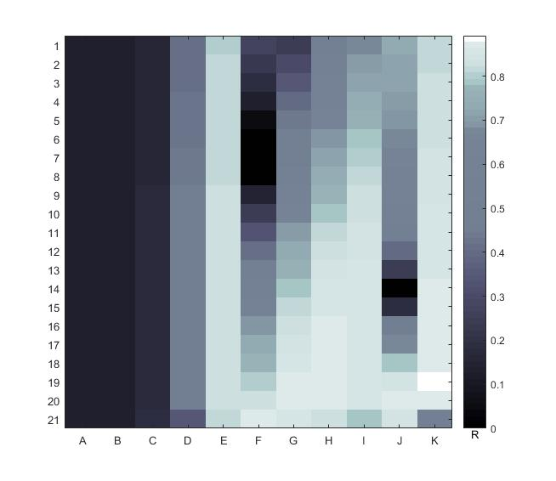

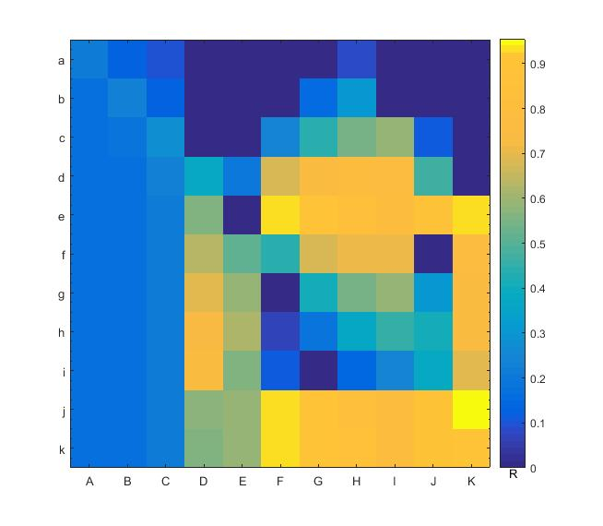

19-K and j-K